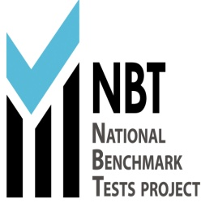

**NBT RESULTS**

**Dear Bianca**

**Herewith confirmation of your NBT results**

|  |  |  |  |  |
| --- | --- | --- | --- | --- |
| **Details** | | **Academic Literacy (AL Score)** | **Quantitative Literacy (QL Score)** | **Mathematics** |
| **NBT Reference number:** | **93100180018348** | **75** | **70** | **61** |
| **ID/Passport number:** | **9902190245082** |
| **Surname:** | **DU TOIT** |
| **First Name:** | **ILNE** |
| **Test Date:** | **24/06/2017** |
| **Venue:** | **ST PATRICKS COLLEGE** |

**Centre for Educational Accessments (CEA)**

**Level 4, Hoerikwaggo building,**

**North Lane, Upper Campus**

**University of Cape Town, Private Bag**

**Rondebosch 7701, South Africa**

**Helpdesk contact number is (021) 650-3523 and email is** [**nbt@uct.ac.za**](mailto:nbt@uct.ac.za)

